**1. Write a python program to reverse a number using a while loop.**

**PROGRAM:**

string = input("Enter the lower case string: ")

rev_string = ""

index = len(string) - 1

while index >= 0:

rev_string += string[index]

index -= 1

print(f"The reversed string is: {rev_string}")

**OutPut:**

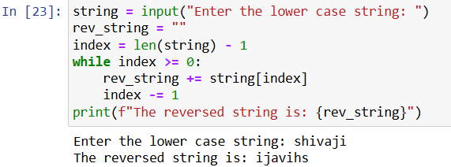

**2. Write a python program to check whether a number is palindrome or not?**

**PROGRAM:**

string = input("enter the lower case string:")

rev_string = ""

for char in string:

rev_string = char + rev_string

if string == rev_string:

print(f"{string} is palidrome")

else:

print(f"{string} is not palidrome")

**OutPut:**

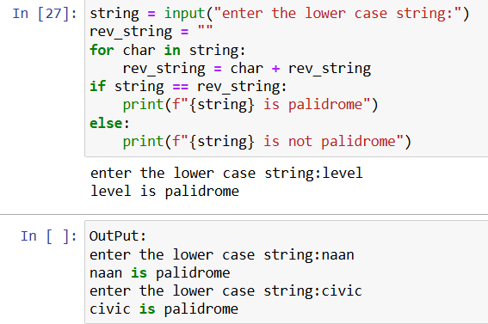

**3. Write a python program finding the factorial of a given number using a while loop.**

**PROGRAM:**

number = int(input("Enter a number to find its factorial: "))

factorial = 1

i = 1

while i <= number:

factorial *= i

i += 1

print(f"The factorial of {number} is: {factorial}")

**OutPut:**

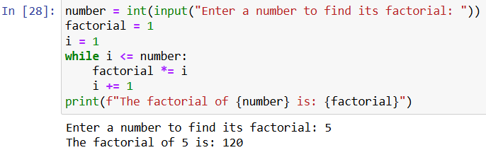

**4. Accept numbers using input() function until the user enters 0. If user input 0 then break the while loop and display the sum of all the numbers**

**PROGRAM:**

total_sum = 0

while True:

num = int(input("Enter a number (enter 0 to stop): "))

if num == 0:

break

total_sum += num

print(f"The sum of all entered numbers is {total_sum}")

**OutPut:**

